Artificial Intelligence: Applications and Issues
Birmingham City University
November 26, 2026

“Desirable Difficulties for the Cyber Gearhead”

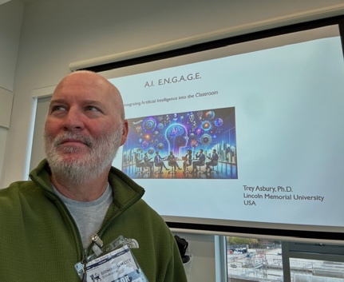
Dr. Titus Asbury, Lincoln Memorial University, USA
As artificial intelligence becomes embedded in everyday workflows, a new class of “power users” is emerging—individuals who leverage AI not just for efficiency, but for cognitive amplification. This talk explores the concept of desirable difficulties—effortful learning conditions that enhance long-term retention and transfer—within the context of AI-assisted work. While AI can streamline complex tasks, overreliance may reduce opportunities for the productive struggle necessary for deep expertise. We examine how intentional friction, strategic constraint, and reflective use of AI tools (i.e. becoming a “cyber gearhead”), can preserve critical thinking, metacognition, and domain mastery. Attendees will gain practical strategies for designing AI-integrated workflows that balance performance gains with sustained cognitive development, ensuring that increased capability does not come at the cost of diminished competence.

